1. Write a Python program to print "Hello Python"?

Ans:

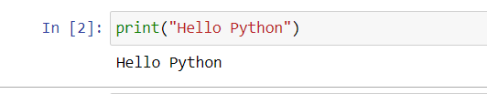

1. Write a Python program to do arithmetical operations addition and division.?

Ans: 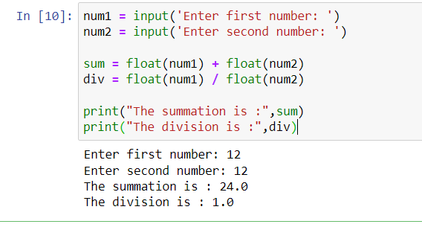

1. Write a Python program to find the area of a triangle?

Ans:

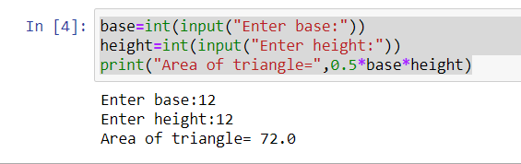

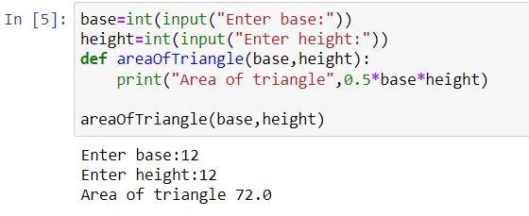

1. Write a Python program to swap two variables?

Ans: 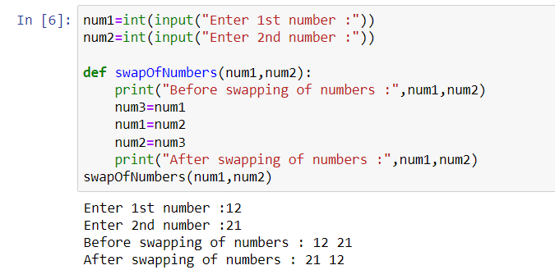

1. Write a Python program to generate a random number?

Ans: 